BAHRIA UNIVERSITY

Karachi Campus



LAB EXPERIMENT NO.05

LIST OF TASKS

|  |  |
| --- | --- |
| TASK NO | OBJECTIVE |
| 01 | While utilizing the Linux commands studied so far, provide an example (other than the one shown in this Lab) of a combination of several Linux commands in which pipes are used more than once. Also provide a snapshot of the generated output. |
| 02 | Write a shell script that records the full path of all the files present within a directory into a record.txt file. Along with full path name, the script should also record the number of words, characters and lines within each file |
| 03 | Write a C program that asks the user to provide an integer input in the main() function. The program would call a function even_odd() from the main() function, where the function even_odd() accepts an integer as an argument, determine and display if the passed integer is either even or odd |

**TASK # 1:** While utilizing the Linux commands studied so far, provide an example (other than the one shown in this Lab) of a combination of several Linux commands in which pipes are used more than once. Also provide a snapshot of the generated output.

**SOLUTION:**

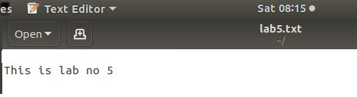

**OUTPUT:**

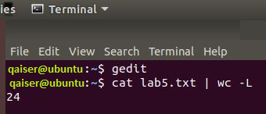

**TASK # 2:** Write a shell script that records the full path of all the files present within a directory into a record.txt file. Along with full path name, the script should also record the number of words, characters and lines within each file.

**SOLUTION:**

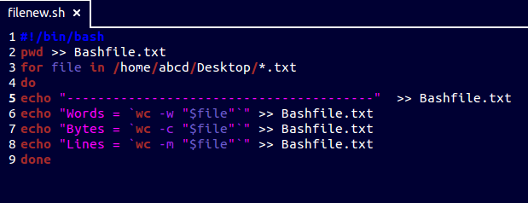

**OUTPUT:**

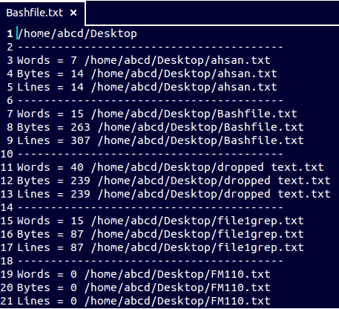

**TASK # 3:** Write a C program that asks the user to provide an integer input in the main() function. The program would call a function even_odd() from the main() function, where the function even_odd() accepts an integer as an argument, determine and display if the passed integer is either even or odd.

**SOLUTION:**

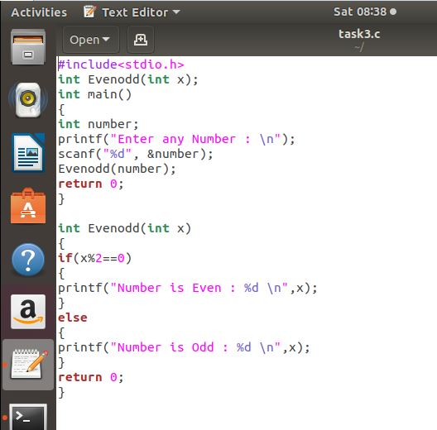

**OUTPUT:**

